ADTA 5560: Assignment 2

Biniam Abebe

**Assignment 2**

1. PART I: Biological Neural Network & Artificial Neural Network (30 Points)

#### Question 1.1:

*Describe the human biological neural network and how it works.*

The human biological neural network is a complex system of interconnected neurons that process and transmit information throughout the body. This network primarily comprises the brain, spinal cord, and peripheral nerves. Here’s a detailed description of how it works, accompanied by illustrations. How It Works: By Receiving incoming signals through their dendrites, the cell body integrates them. If the combined signal strength exceeds a certain threshold, an action potential (electrical impulse) is generated. Action Potential Generation An action potential is a rapid change in electrical charge across the neuron's membrane. The action potential travels down the axon to the axon terminals. When the action potential reaches the axon terminals, it triggers the release of neurotransmitters into the synaptic cleft. (Diego,2018)

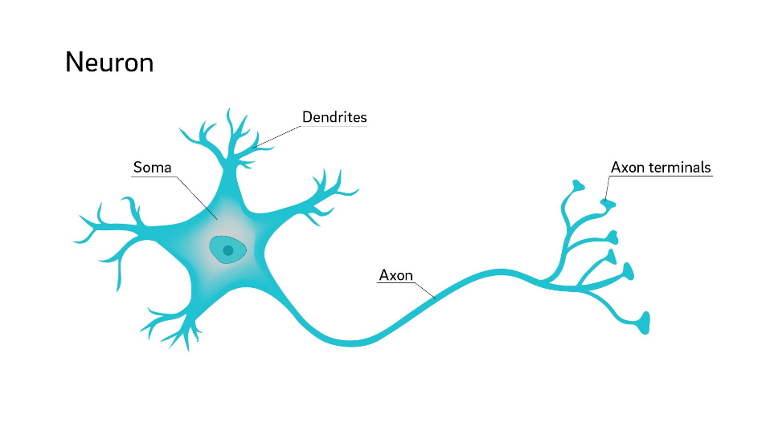

#### Question 1.2:

*Describe (including* ***images*** *for illustration) the McCulloch-Pitt neuron model, a.k.a. Threshold Logic Unit, considered the simplest neural network, and how it works.*

The McCulloch-Pitt neuron model is a simplified model of real neurons known as the Threshold Logic Unit. A set of synapses (i.e., connections) brings the activations from the other neurons. A processing unit sums the inputs and applies the non-linear activation function (i.e., threshold/transfer function).

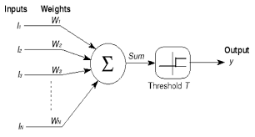

#### Question 1.3:

*Discuss (including* ***images*** *for illustration) how the pioneers in the AI field imitated the human biological brain system to conceive the first artificial neural networks.*

When artificial intelligence was originally invented, it replicated the human brain system to produce the first artificial neural network. The brain and artificial intelligence have had a mutually beneficial relationship throughout history. Throughout history, the brain has served as the primary source of inspiration for the development of artificial intelligence systems and breakthroughs in artificial intelligence, leading to a greater knowledge of the brain and its activities. When it comes to the brain and artificial intelligence, knowledge and ideas are exchanged reciprocally. There are various examples that highlight the favorably synergistic nature of this interaction. In my perspective, one of the most significant contributions of the human brain to Artificial Intelligence has been the development of Neural Networks. It is critical to recognize that Neural Networks are computational models that simulate the behavior and structure of biological neurons. The interactions and adaptations of neurons within the brain have had an impact on a wide range of learning algorithms and neural network architectures.

1. PART II: Linear Algebra for Deep Learning: Matrices (20 Points)

***Given the following matrices:***

$A = \left[\begin{matrix}5 & 3 & 8 \\ 2 & -1 & 7\end{matrix}\right]$

* ***Matrix B, with its scalar elements***

***B = $\left[\begin{matrix}1 & 2 \\ 3 & 4 \\ 5 & 6\end{matrix}\right]$***

* ***The result of C = A * B***

**C = $\left[\begin{matrix}54 & 70 \\ 34 & 42\end{matrix}\right]$**

* ***Specify the dimensions of C***
  + Metrix A is 2 by 3, while Matrix B is 3 by 2. The result Matrix C is 2 by 2 dimensions.
* ***Explain how to get the dot product C = A * B***

To calculate the dot product of two matrices, we start with the first row of the first matrix and the first column of the second matrix, multiply the appropriate items in both rows and columns and add up the products. We do this for all the

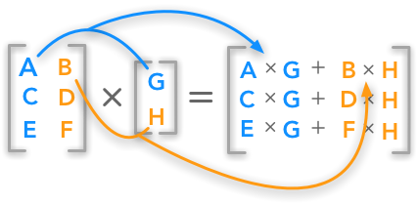

1. PART III: Linear Algebra for Deep Learning: Matrices (30 Points)

Given the following matrix as a 2D array:

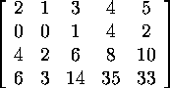

#### --) Question 3.1:

* ***How many vector elements does this matrix have?*** 
  + It has 4 Vectors
* ***Show each vector element one by one.***

The following vector elements:

1. [2,1,3,4,5]
2. [0,0,1,4,2]
3. [4,2,6,8,10]
4. [6,3,14,35,33]

#### --) Question 3.2:

***Let’s consider this matrix as a vector of vectors. Add 3 to the element vector (of the matrix) at the index = 1. The addition is performed elementwise along Axis 1. Display the matrix with all its scalar elements after the operation has been done in the format of a 2D- matrix.***

Given:

Index 1 vector: [0,0,1,4,2]

Sum 3 to each of the elements

[0+3,0+3,1+3,4+3,2+3]

Result: **[3 3 4 7 5]**

***Display the matrix with all its scalar elements after the operation has been done in the format of a 2D- matrix***.

Answer :

$\left[\begin{matrix}\begin{matrix}2 & 1 & 3 & 4 & 5 \\ 3 & 3 & 4 & 7 & 5 \\ 4 & 2 & 6 & 8 & 10 \\ 6 & 3 & 14 & 35 & 33\end{matrix}\end{matrix}\right]$

#### --) Question 3.3:

***Continuing from Question 3.2, i.e., after the above addition of 3 has been done:***

***Flatten the matrix and display the result.***

Flattened matrix: [2, 1, 3, 4, 5, 3, 3, 4, 7, 5, 4, 2, 6, 8, 10, 6, 3, 14, 35, 33]

**Reference**

1. Diego, U. o. C. Why are neuron axons long and spindly? study shows they're optimizing signaling efficiency. Retrieved from https://medicalxpress.com/news/2018